
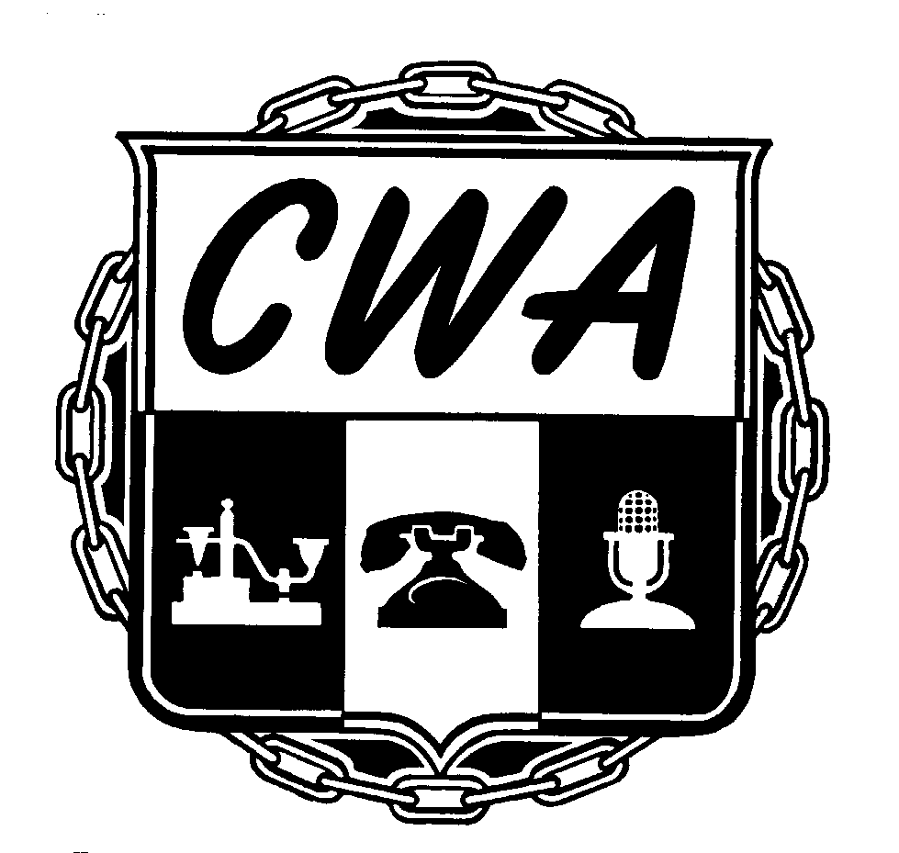

We Stood Up!

New Contract with Verizon Defeats the Most Aggressive
Attack Ever on the Living Standards of Our Members,
Preserves Job and Retirement Security for 34,000

On September 19th, the CWA reached a tentative agreement with Verizon Communications that protects the job security and retirement security of our 34,000 members from Virginia to Massachusetts.

A new contract was also negotiated between Verizon Wireless and 70 CWA-represented technicians who maintain cell sites in the metropolitan New York area.

Our new contract was won only after a militant two-week strike in August, 2011, and an ensuing 13 month on-the-job membership contract campaign that mobilized tens of thousands of members. It also took the support of literally hundreds of our allies, in labor and community groups all across the country, who adopted our struggle as their own, leafleted Verizon Wireless stores, joined our picket lines and rallies, and pressured Verizon management however they could.

“Our members stood up to the most sweeping and intensive attack on our standard of living and bargaining rights in the history of the telecommunications industry,” said Chris Shelton, Vice President for CWA District One, which stretches from Maine to New Jersey. “The unity and determination of 34,000 CWA members since bargaining began in June, 2011 has produced a new agreement that preserves intact our members’ pension and job security, provides for a substantial wage increase, and preserves a high-quality health plan.

“The solidarity of CWA members and the support of our progressive allies made this contract happen,” said Ed Mooney, Vice President of CWA District 2-13, which covers CWA members from Pennsylvania to Virginia. “Verizon workers will keep their standard of living and the benefits and working conditions we've fought for over the years.”

The achievements of this contract fight can be seen just by going back to a list of what was on the table when bargaining began 15 months ago : a sweeping list of take-back demands that included
- no guaranteed raises,
- elimination of night and weekend differentials,
- elimination of double time pay,
- freezing of pension accruals and elimination of the pension cash-out option,
- eliminating all job security provisions for all employees,
- eliminating the movement of work protection and the 35 mile transfer provision,
- slashing the Sickness and Accident Disability Plans in half,
- eliminating the New Contracts Initiative,
- totally gutting the medical plan with huge premiums, and unreasonable co-pays and deductibles, and
- reducing sick time pay to 0-5 days depending on seniority.

Your determination and solidarity got us a contract that fully protects our members’ job and retirement security, including no-layoff provisions and movement of work limitations, preserves an extremely high-quality medical plan with modest increases in deductibles and co-pays and limited premium sharing, provides for an 8.2% compounded wage increase over the life of the agreement, with additional cash payments, and bringing hundreds of new jobs into the bargaining unit.

Highlights of the new agreement include:

Job Security Preserved:
- Existing job security language, including a prohibition on layoffs, forced transfer or downgrade of workers hired before 2003 and the .7% restriction on the company’s ability to relocate work out of the region, were preserved intact.
- Provisions of the contract which restrict the company’s right to reassign workers long distances from their homes (35-mile rule) have been preserved.
Retirement Security Preserved:
- The existing defined benefit pension plan has been preserved for all current employees, including the lump sum cashout provisions.

8.2% Compounded Wage Increased Plus Other Compensation:
- Wage increases of 2.25% effective the first Sunday after ratification, 2.75% effective August 4, 2013, and 3% effective August 3, 2014. This amounts to an 8.2% wage increase with compounding.
- In addition, members will receive a $800 signing bonus 30 days after ratification of the new agreement.
- There will be annual corporate profit-sharing payments of at least $700 per year.
New Bargaining Unit Jobs
- Verizon will hire 300 new full-time call center employees during the life of the contract
- Verizon New York will bring back into the bargaining unit certain underground cable placing work currently performed by contractors in upstate New York.
Medical Plan
- CWA members at Verizon will continue to have access to the most comprehensive, lowest-cost health care plan in the industry.
- The unions and Verizon negotiated revisions to the current health plan that require workers to make modest contributions toward the cost of health care premiums. For participants in the MEP and HCN, these payments will start at $60 per month for family coverage and $30 per month for individual coverage as of November 2012, and rise over the remaining years of the contract to $110 family and $55 individual per month at the conclusion of the four year contract.
- For participants in the EPO, HMOs and other plans, payments will start at $45 individual and $90 family, and rise to $82.50 individual and $165 family by the end of the agreement. These rates are higher because there are no deductibles in these plans.
- These premiums include a $100 credit for employees who participate in an on-line health care assessment survey.
- Effective January 1, 2013, Verizon will contribute $850 to a tax-free Health Reimbursement Account (HRA) for current employees which can be used to offset increased out of pocket costs under the new health plan, and can be carried over from year to year at the employee’s discretion.
- Any retiree who leaves service before January 1, 2013 will not be required to contribute to the cost of retiree medical care.
- Employees who were hired after August 3, 2008 will see an increase in their retiree medical care accrual from $430 to $480 per year of service towards the coverage of the cost of health care.
Absence
- Effective January, 2013, there will be changes to contract provisions covering paid absence days. Payment for incidental absence (personal illness or off-duty accidents) will be capped at 10 days.
- Four incidental absence days per year shall not be subject to the Absence Control Plan.
- Employees who use four or less absence days per year will be awarded a lump sum payment as follows:
  - Employees with perfect attendance will receive a lump sum payment of five days’ pay.
  - Employees who use less than two days will receive four days’ pay.
  - Employees who use less than 3 days will receive 3 days’ pay.
  - Employees who use less than 4 days will receive 2 days’ pay.
  - Employees who 4 days will receive 1 days’ pay.
- According to company figures, in 2011, 76% of our members used fewer than 10 days of absence. 48% of our members would have received one of the incentive payments listed above, based on their absence record. 29% would have received a week’s pay.
- Accident and Sickness Disability remains unchanged.
Additional Contract Provisions
- Employees hired after ratification will be covered by a 401(k) retirement program that provides a 100% company match for any employee contributions up to 6% of salary. They will also receive an annual discretionary bonus of up to 3% of their salary added to their 401(k).
- Contract provides continuing funding to the Work-Family Committee of $1.5 million per year ($6 million over the life of the contract).
- The TTA/Next Step program will be phased out over the life of the agreement.
- Any member currently enrolled in TTA/Next Step will be entitled to complete the program and retain that title and associated wages and benefits.
- Tuition Assistance Program will be capped at $8,000 per year.
Workers Fired During 2011 Strike
- Upon ratification, 25 of the 26 CWA members fired during the strike will be returned to work, with restoration of full Net Credited Service and pension benefits.
- We are working on a settlement for one worker

There are changes in our health care that will result in premiums and plan design changes which will result in some increased out-of-pocket expenses. However, when wages and the company-funded tax-free Healthcare Reimbursement Accounts (HRAs) are factored in, CWA members will be better off, financially, at the end of this round of bargaining than they were at the start.
We started this round of bargaining with the best contract in the telecommunications industry. Your bargaining team is convinced that despite the intense attacks from Verizon, we have negotiated a contract that remains the BEST in the telecommunications industry.

